Solutions for the latest in welding production
EWM accompanies customers on the path towards Industry 4.0

Supporting customers as they work towards intelligently networked production to create lasting competitive advantages – with this goal in mind, EWM AG is making significant advancements in the digitisation and development of welding production. Germany’s largest supplier of arc welding technology offers countless products and solutions that meet the most modern production process requirements in the age of Industry 4.0. Among these are the welding 4.0 management software ewm Xnet and the new MIG/MAG multiprocess welding machine Titan XQ.

The fourth industrial revolution is in full swing: many companies are facing the challenge of equipping their operations for the future with an intelligent man-machine network that increases productivity. The resulting analysis of all process data makes unused potential visible and provides a decisive advantage on the global market. As Germany’s largest supplier of arc welding technology, EWM has been driving the development of innovative technology solutions in the field of welding production for years. ewm Xnet is one example: the Welding 4.0 welding management system ensures real added value in welding-related production. The latest evolution of the software assists with the organisation of production, planning, quality management, and welding coordination personnel in one coherent system. Welding companies of all sizes and orientations benefit from the numerous advantages that Industry 4.0 is already offering today.

The right solution, individually
As a technology driver, EWM is constantly working on new products and solutions that meet the complex requirements of networked welding production. Titan XQ is the new flagship of MIG/MAG multiprocess welding machines from EWM and is seamlessly integrated into this concept. With wide-ranging network capabilities, the welding machine is part of the Internet-of-Things (IoT). The machine provides welding data via the ewm Xnet management system interfaces. It recognises potential for optimisation and allows for the advancement of individual components, processes, and entire company departments. Big Data becomes a reality with the automatic documentation and evaluation of welding parameters. With the welding 4.0 solutions from EWM, the customer’s facility becomes a Smart Factory.

Big Data becomes a lived reality
For all new developments, the welding technology manufacturer relies on intuitive, self-explanatory controls to efficiently design the man-machine interface. Use of the new, intelligent PM welding torch, for example, brings this interface directly into the welder’s hand and, therefore, even closer to the weld seam. This means that the user always has an eye on important parameters such as gas or wire supply while welding.

With the digitisation of all welding machines with highly intelligent microprocessors, interfaces, and network connections, EWM meets all the requirements for Big Data process data collection. This information can be displayed in the user’s primary systems via standardised industrial interfaces, such as OPC-UA. This allows for machine efficiency analyses and preventative maintenance.

Support of forward-thinking projects
EWM is already working on solutions for tomorrow’s needs. To do so, the company is working together with Seabery and Weldplus, among others, on the welder’s qualification for the Soldamatic augmented reality trainer. EWM also awards the implementation of future-orientated research projects with the EWM Award, an endowment of 30,000 euros. The company is currently supporting the development of a real time augmented reality assistant system for real welding, for example.

- Date: 25 September 2017
- Scope: 3,341 characters including spaces
- Images:

Image 1:
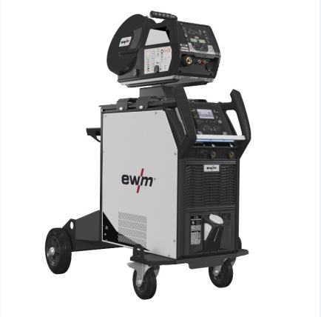
As a technology driver, EWM is constantly working on new products and solutions that meet the complex requirements of networked welding production. The new Titan XQ multi-process MIG/MAG machine series is seamlessly integrated into this concept

Image 2:
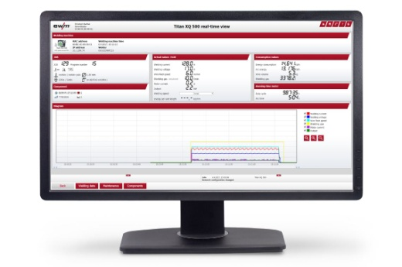
The latest evolution of the software assists with the organisation of production, planning, quality management, and welding coordination personnel in one coherent system.

Image 3:
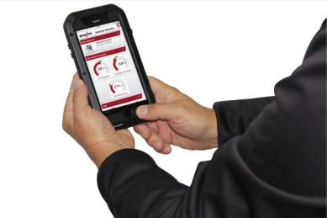

Big Data becomes a reality with the automatic documentation and evaluation of welding parameters. With the Welding 4.0 solutions from EWM, the customer’s facility becomes a Smart Factory

For more high-resolution images, please see: www.ewm-group.de

- About EWM:
EWM AG is Germany’s largest manufacturer of arc welding equipment and one of the most important suppliers of this technology worldwide. The family-run company offers a complete range of systems for first class welding. From welding machines, welding torches and welding consumables to accessories for manual and automated applications, EWM offers everything from a single source. The company takes technological responsibility for the entire welding process. In addition, customers also benefit from a comprehensive range of services. This also includes the innovation and technology consulting “ewm maXsolution”. EWM has a strong global presence with approximately 600 employees based at twelve German and seven international locations, supported by more than 400 sales and service outlets worldwide.
Thanks to their extensive, highly innovative development work in products and welding procedures, EWM is considered by competitors and users to be one of the industry’s primary drivers of welding technology. EWM brings the added value of Industry 4.0 to welding production with intelligently networked and productivity-enhancing solutions. The company’s passion for welding is clear from its guiding motto ‘WE ARE WELDING’. Together with the “BlueEvolution” sustainability initiative, the aim is to meet the specific customer requirements in the best possible way – always taking into account cost-effectiveness and ecology. Users benefit from energy-saving welding processes, significantly lower use of raw materials, reduced emissions and shorter overall production times. As a result, this leads to significant cost and resource savings. In this way, customers can boost their competitiveness while also protecting the environment.

EWM AG contact details
Frank Stremlau/EWM AG
Dr. Günter-Henle-Str. 8 / 56271 Mündersbach
Tel.: +49 2680 181 472
Email: Frank.Stremlau@ewm-group.de / Internet: www.ewm-group.com

Press contact
Nils Heinen / additiv pr GmbH & Co. KG
Public relations for logistics, steel, industrial goods and IT
Herzog-Adolf-Strasse 3 / 56410 Montabaur
Tel.: +49 2602 950 9913 / Fax: +49 2602 950 9917
Email: nih@additiv-pr.de / Internet: www.additiv-pr.de

