Thank you for your expertise and loyalty
EWM honours long-standing employees

They have been part of the EWM family for 10, 20, 25 and even 30 years: 28 employees celebrate their workplace anniversaries at Germany’s largest welding machine manufacturer headquartered in Mündersbach. The family-run company has a tradition of long-standing employees. More than half of our employees have been at the company for well over ten years, says Angelika Szczesny-Kluge, Member of the EWM Executive Board for HR.

“In large companies, you’re just a number – but EWM is a like a big family”, explains Franz Schmidt. Like Jürgen Pfeiffer and Mario Pfeiffer, Schmidt has been part of the EWM team for 30 years. Holger Klett and Peter Schönberger have been contributing to the company’s success for a quarter of a century. Winfried Hahmann, Stefan Giebl, Nils Bajohr, Linda Altgeld, Thorsten Erdnüß, Jutta Petersdorf, Willi Wiens and Nicole Löhr have had a positive influence on the welding machine manufacturer for two decades. Jörg Kaulbach, Olaf Brandstädter, Evelin Lange, Claudia Feierabend, Erdogan Sari, Volker Simon, Veronika Klein, Larissa Dürksen, Kai Neuer, Frank Hoffmann, Peter Willamowski, Erika Platt, Johannes Rosbach, Jürgen Schneider and Hans-Peter Mandler are celebrating ten years with EWM.

Thank you for your expertise and competence
Angelika Szczesny-Kluge thanked all the employees: “We are very happy that you have supported us with your expertise and competence for so long!” It is great to know that there are so many loyal employees at EWM, especially during these times of specialist staff shortages.

She also emphasised that loyalty and appreciation are mutual. This is why the welding machine manufacturer is committed to taking care of its employees. From apprenticeships in a wide range of professions, help in finding accommodation if they move to another site, to contributions for gym memberships and support packages for parents, the company supports its employees in many aspects of their daily lives. Plus, there are also numerous career opportunities worldwide in a future-proof and innovative industry.

“It all contributes to the fact that often multiple generations of the same family work for us, and many for decades”, noted Angelika Szczesny-Kluge.

Date: 12 November 2018
Scope: 3,266 characters, including spaces
Figures: 1

Fig. 1:
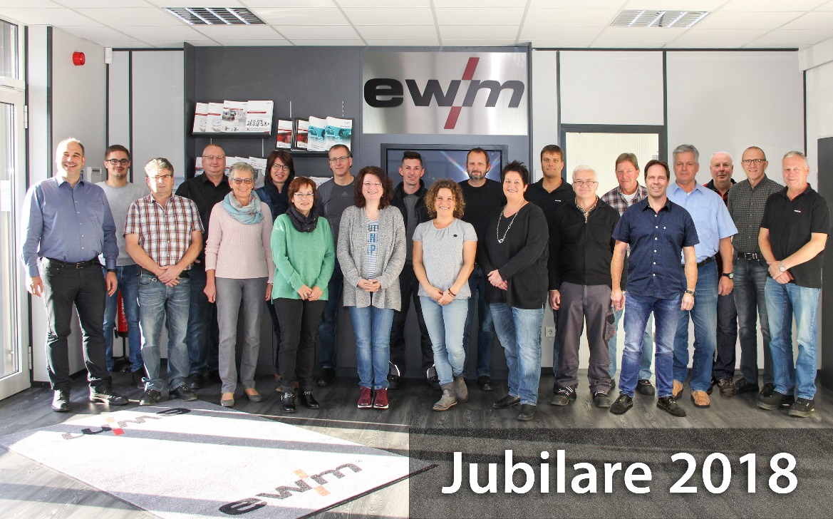

Members of the EWM family for 10, 20, 25 and 30 years (from left to right). Stefan Giebl, Johannes Rosbach, Jürgen Pfeiffer, Mario Pfeiffer, Veronika Klein, Claudia Feierabend, Jutta Petersdorf, Peter Schönberger, Evelin Lange, Peter Willamowski, Linda Altgeld, Holger Klett, Nicole Löhr, Kai Neuer, Willi Wiens, Volker Simon, Nils Bajohr, Olaf Brandstädter, Franz Schmidt, Winfried Hahmann and Jürgen Schneider.

About EWM:
EWM AG is Germany’s largest and one of the most important worldwide manufacturers of arc welding technology. The family-run company from Mündersbach has been living their motto, “We are welding”, for over 60 years with forward-looking, well thought-out and sustainable complete solutions designed with a large helping of passion for industrial clients, as well as skilled craft businesses.
EWM develops high-end welding technology. The company, based in Germany’s Westerwald region, offers complete systems that cover everything from high-quality welding machines (and all associated components), through welding torches, to welding consumables and accessories for manual and automated applications. EWM has made a name for itself worldwide thanks to its plants in Germany, China and the Czech Republic. Users praise the products’ ease of operation and excellent results. Companies value the solid consultancy, service and enormous savings that come with EWM systems. The welding processes, some of which are patented, reduce the consumption of materials, energy and time during operation, and produce up to 75 percent fewer welding fume emissions.
The innovative welding manufacturer currently employs around 700 employees at 14 German and 7 international locations, with just under 400 of these being based at their original headquarters in Mündersbach.

EWM AG company contact
Maja Wagener
Dr. Günter-Henle-Str. 8
56271 Mündersbach, Germany
Telephone: +49 (0)2680 181-434
Email: maja.wagener@ewm-group.com
Internet: www.ewm-group.com

Press contact
additiv pr GmbH & Co. KG
Nils Heinen
Public relations for logistics, steel, industrial goods and IT
Herzog-Adolf-Straße 3
56410 Montabaur, Germany
Telephone: +49 (0)2602 950 99-13
Email: nih@additiv-pr.de
Internet: www.additiv-pr.de

