EWM at Euroblech
Welding 4.0 in practice – the next generation

“Welding 4.0 – Next Step, Next Generation” – this is EWM AG’s motto for Euroblech where they will present practical welding technology of the future for trade and industry. The demonstrations at Stand E78 in Hall 13 will focus on the manufacturer’s innovative welding processes. Users can experience live how these technologies help them to save energy and cut costs, as well as reduce welding fumes.

The manufacturer will also present new variants of its Titan XQ puls MIG/MAG multi-process welding machine series: in addition to a compact variant with integrated eFeed wire feed mechanism, EWM will demonstrate for the first time the Titan XQR for automated robot applications. Fittingly, the company will also show off its skills in the field of automation – from entry-level solutions collaborating with robots up to complete robotic solutions for industrial welding.

The focus will also be on the extensive connectivity of machine technology offered by the ewm Xnet Welding 4.0 welding management system and its component management. Furthermore, EWM will present new machines from the Taurus Steel series which have been specially developed for steel processing operations for trade and industry.

Date: 26 July 2018
Scope: 1,190 characters, including spaces
Figure: 1

Fig. 1:

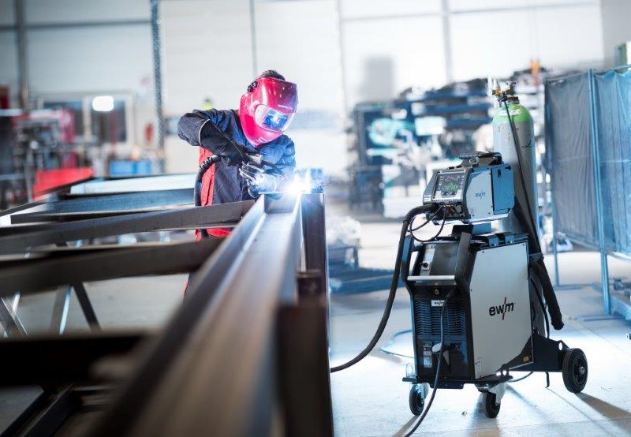

At Euroblech, EWM will present the technology of the future for manual and automated welding applications.

EWM AG company contact
Heinz Lorenz
Dr. Günter-Henle-Str. 8
56271 Mündersbach, Germany
Telephone: +49 2680 181-126
Email: heinz.lorenz@ewm-group.com
Internet: www.ewm-group.com

Press contact
additiv pr GmbH & Co. KG
Nils Heinen
Public Relations for Logistics, Steel, Industrial Goods and IT
Herzog-Adolf-Straße 3
56410 Montabaur, Germany
Telephone: +49 2602-950 99-13
Email: nih@additiv-pr.de
Internet: www.additiv-pr.de

